**Batch Number: B.N-013/25-AWS / DevOps**

**Name: Omkar Korde**

**Topic: maven installation**

**Steps: -**

1. **Start and connect EC2 instance to bash**

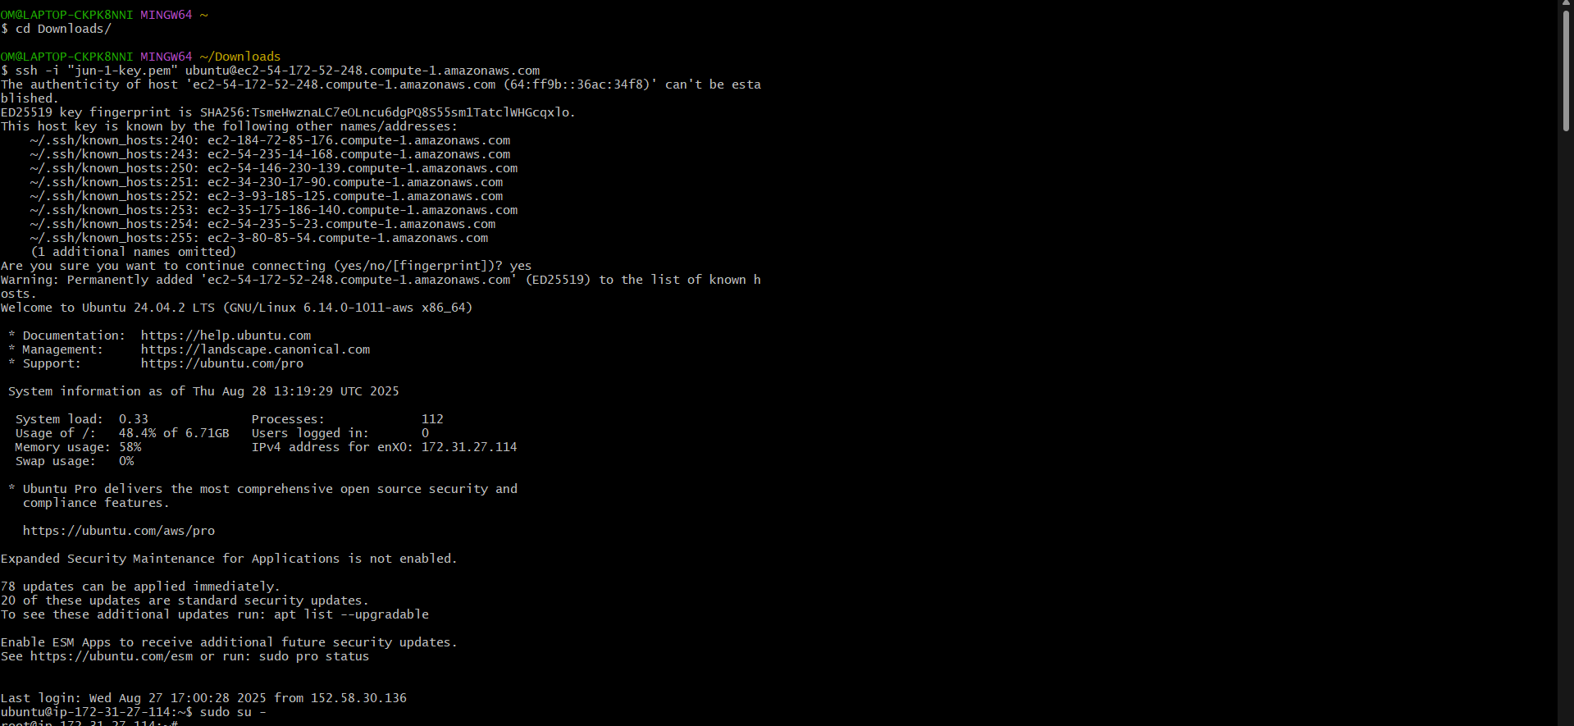

1. **Go to mnt folder. Use “cd /mnt” command**
2. **Go to chrome and search Apache maven download**
3. **Copy the zip file**
4. **Use wget to download from internet “wget** [**https://dlcdn.apache.org/maven/maven-3/3.9.11/binaries/apache-maven-3.9.11-bin.zip**](https://dlcdn.apache.org/maven/maven-3/3.9.11/binaries/apache-maven-3.9.11-bin.zip)**”**

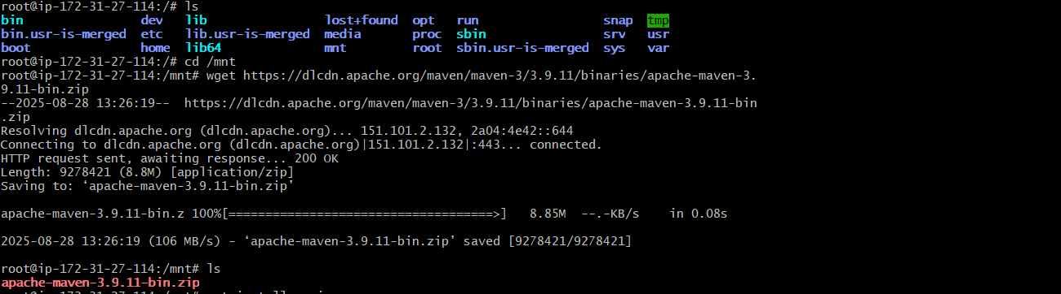

1. **Unzip the apache maven**



* **Unzip successfully**



* **Downloaded version of maven**

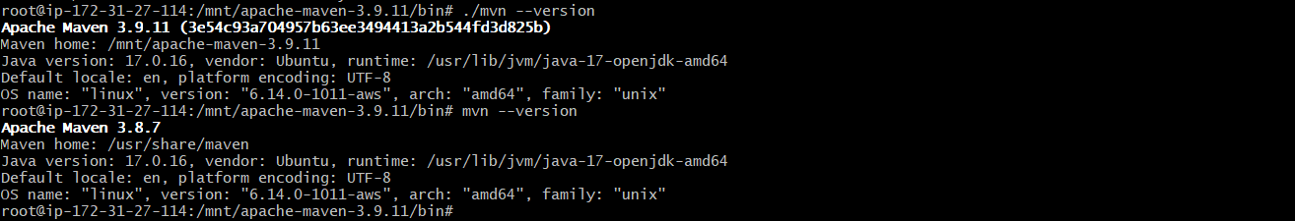

* **Now we can access Apache maven from /mnt/bin to access from home path**

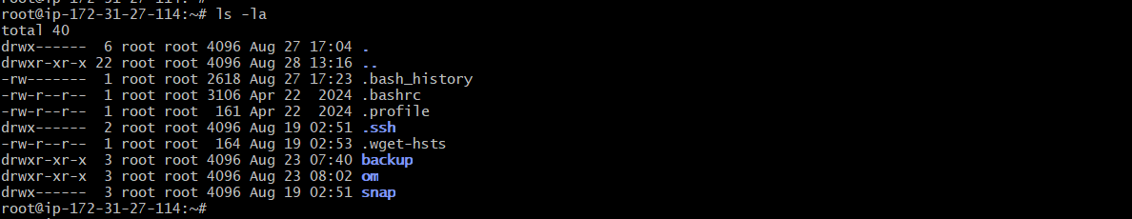

1. **Go in .bashrc “vi .bashrc” add this in file**



1. **Save this and quit from the file**

* **Now we can access Apache maven from home path**

1. **Open Jenkins with the help** 54.172.52.248:8080 **public Ip**
2. **Go to Jenkins manage > tools > add maven**
3. **Untick install automatically**
4. **Give name and home path**

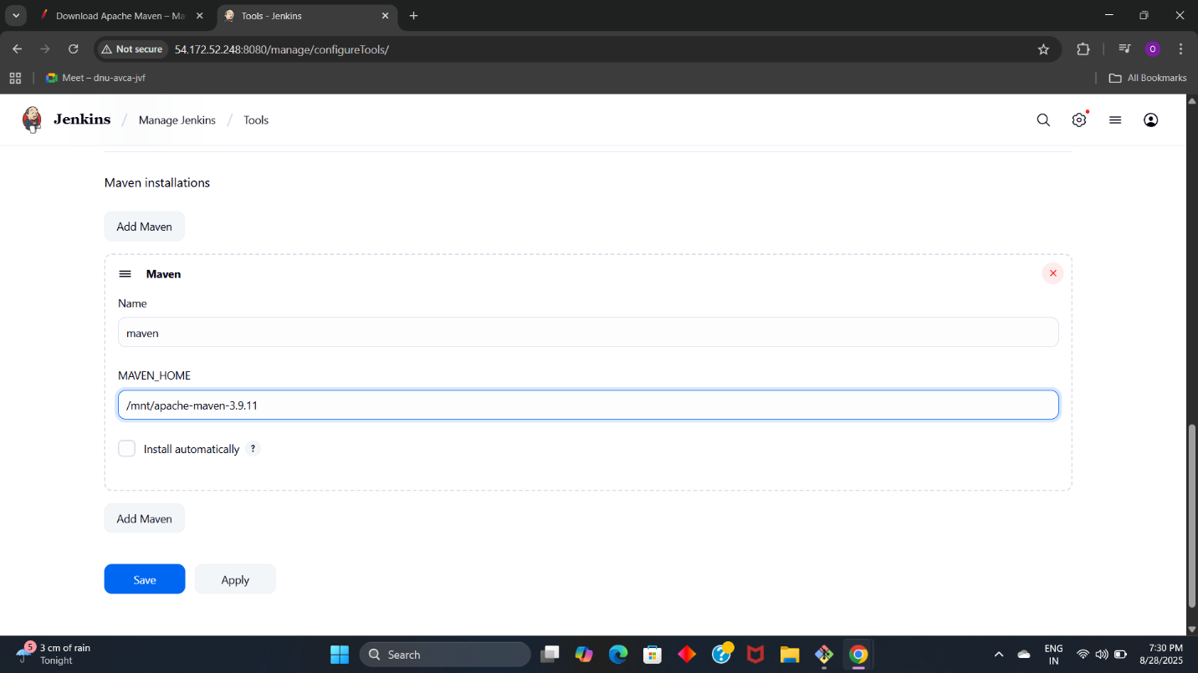

**13. apply and save**